Name ___________________________________________ Block ________________

Review for Assessment #2 (No Calculators)

6.NS.5 UNDERSTANDING INTEGERS

1. Nicole travels 4 miles east of her house to the park.

Part A How many miles and in what direction would she need to travel to return to her house?

Part B Represent the travel to the park and back home as an equation of a sum of integers.

2. Suppose time is measured in years and 0 stands for the year you were born.
a. What rational number represents your age 11 years later? __________
b. Your parents moved into their house 5 years before you were born. Write a rational number to represent this event. ______________
c. How many years after moving into their house will you be 11 years old? __________

3. Given the elevation of a city, how could you tell whether it was located above or below sea level? Explain your answer and give examples.

4. On the same winter morning, the temperature is −4° F in Portland, Maine and 57° F in Richmond, Virginia. How many degrees warmer was it in Virginia than in Maine on that morning? Show your work.

5. At the NEMS book fair, people can win a prize if they can guess how many chocolates are in a glass jar. The person with the closest answer will win the prize. Angie guessed that there are 97 chocolates. Steve guessed that there were 82 chocolates. There were actually 85 chocolates in the jar.

- Write an integer to represent the amount by which Angie’s guess was different from the actual value.

- Write an integer to represent the amount by which Steve’s guess was different from the actual value.

- Who would win the prize?

- What would 0 represent in this situation?

6. What is the value of ? What is the value of – (9)? What is the value of |-2|?

7. If 0 seconds represents the time I start running in a race, what do the following integers represent?

a) -35 _______________________________________________

b) 20 ________________________________________________

c) -18 _______________________________________________

8. Tyquan and Bernice live in the same neighborhood. The store is the same distance from each of their homes. If Tyquan and Bernice live 6 blocks apart, how far do each of them live from the store? Use appropriate math vocabulary to explain how you determined your answer. Show your work on the diagram below.

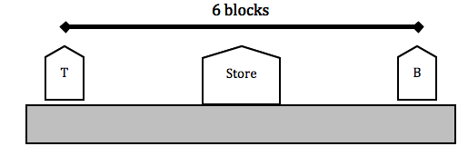

6.NS.6 NUMBER LINES

9. Graph the following numbers and their opposites on a number line: -5, 8, -2

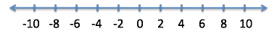

10. Which of the following best describes the location of point C?
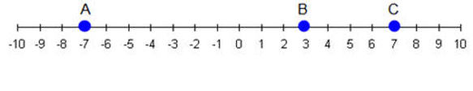
A. -(7) B. -7 C. (-7) D. - (-7)

11. Plot and label the following numbers in the correct places on the number line.
A. | -3 | B. 1.5 C. -0.75 D. E. | 4 | F. -2 ¼

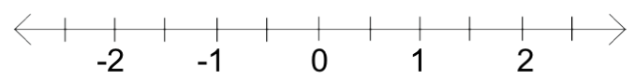

6.NS.7 COMPARING, ORDERING, AND FINDING ABSOLUTE VALUE OF RATIONAL NUMBERS

12. Which integers are greater than -25 and less than -15? Select all answers that are correct.

A. -21 D. -26
B. -41 E. -10
C. -3 F. 0

13. John needed to complete a report for his science class. He recorded the temperatures in four cities around the world. List the temperatures in order from least to greatest.

Buenos Aires: 78° San Diego: 52°
Moscow: -10.5° Seattle: - 4°

14. List the following temperatures in order from the warmest to the coldest:

32°, 0°, -2°, 62°, -8°, 98°, -13°, 78° and 45°

15. One thermometer reads -12° and the other reads -5°. Which inequality shows the relationship between the temperatures on the two thermometers?

A. - 5 > - 12 B. - 12 > - 5 C. - 5 > 0 D. - 12 > 0

16. One thermometer reads -9° and the other reads -20°. Write an inequality ( <, >, or = ) that shows the relationship between the temperatures on the two thermometers.

-9 _____ -20

17. A buried treasure is found 130 feet below sea level. Which of the following represents the treasure’s elevation?

A. |-130|= -130 feet B. |130| = 130 feet

C. |-130| = 130 feet D. |130| = -130 feet

18. Greg states that he was scuba diving 550 feet below sea level, and he can write that as |-550|. Is he correct? Why or why not?

19. Lindsey’s bank account balance showed a debt greater than $100.

Part A: Tell whether each of the following statements are true or false.

_____ Linsdsey’s balance is greater than -100.
_____ Linsdsey’s balance is less than -100.
_____ Linsdsey’s balance is equal to 0.
_____ Linsdsey’s balance is equal to -100.

Part B: Which of the following could be Lindsey’s overall balance?

A. $100 B. - $105 C. - $90 D. $0

Part C: What are three other values that would represent a debt greater than $100?

____________ ____________ ____________

20. Terra’s bank account balance showed a debt less than $30.

Part A: Tell whether each of the following statements are true or false.

_____ Terra’s balance is greater than -30.
_____ Terra’s balance is less than -30.
_____ Terra’s balance is equal to 0.
_____ Terra’s balance is equal to -30.

Part B: Which of the following could be Terra’s overall balance?

A. - $26 B. - $0 C. $30 D. - $31

Part C: What are three other values that would represent a debt less than $30?

____________ ____________ ____________

21. Fill in the following blanks using <, >, or =.

a) -12____-14 b) |-29|____-26 c) -16 _____ |16|

d) -|-15|____15 e) -(-36)____36 f) -(-4) _____ -|-4|

