Name _______________________________________________ Date __________________

Assessment 9 Review Guide (Calculators Allowed)

6.SP.1 Statistical Questions
1. Emily is collecting data about Cecil County residents’ favorite summer activities. Write a statistical question that best represents this scenario.

2. Zeke likes to collect buttons and he keeps them in a jar. Zeke can empty the buttons out of the jar, so he can see all of his buttons at once.
- Which of the following are statistical questions that someone could ask Zeke about his buttons? For each question, explain why it is or is not a statistical question.

  - What is a typical number of holes for the buttons in the jar?

  - How many buttons are in the jar?

  - How large is the largest button in the jar?
  - What is a typical size for the buttons in the jar?

  - How are these buttons distributed according to color?

b. Write another statistical question related to Zeke’s button collection.

3. Which of the following are statistical questions? Rewrite each non-statistical question as a statistical question.

- How many days are in March?

- How old is your dog?

- How many bricks are in this wall?

- On average, how old are the dogs that live on this street?

- What proportion of the students at your school like watermelons?

- Do you like watermelons?

- What was the highest temperature today at City Hall?

6.SP.2 Data Displays 6.SP.4 Dot Plots and Box & Whisker Plots
6.SP.3 Measures of Center and Variability 6.SP.5 Summarize and Describe Data

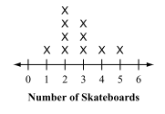
4. A group of students were surveyed to determine how many skateboards they owned. The dot plot shows the results of the survey. Determine measures of center and range by determining the mean, median, mode, and range for the set of data.

Mean ___________ Mode ___________

Median ___________ Range ____________

Use the histogram on the right to answer #5 – 9.
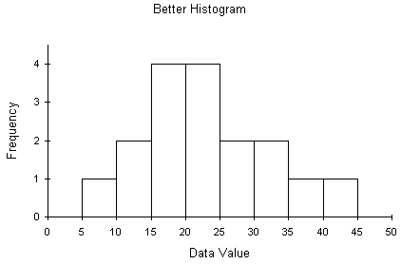
5. Which statement accurately describes the data shown in the histogram?

- The range is from 0 – 50
- The median is 20 – 25
- The data is skewed left.
- 50% of the data is below 25.

6. How many values are at least 35?

7. How many values are less than 15?

8. Describe the spread of the data
(What is the range? Is the data symmetric?)

9. Describe the shape of the data.
(Is it grouped to the right or left? Is it skewed? Is there a peak?)

10. Sharon’s Quiz Scores: 86, 97, 99, 100, 75, 91, 79, 80, 82, 88, 86, 75, 86, 91, 81
a) How many quizzes did Sharon take?

b) Create a dot plot of the data.

c) Determine the mean of the data set. Describe what this value means in the context of the problem.

d) Determine the median of the data set. Describe what this value means in the context of the problem.

e) Determine the range of the data set. Describe what this value means in the context of the problem.

11. 4, 6, 7, 9, 15, 18, 20, 23, 27, 31, 33, 35

a) List the 5 number summary and the interquartile range, then draw a box-and-whisker plot.

Minimum: ___________
Lower Quartile: ___________
Median: ___________
Upper Quartile: ___________
Maximum: ___________
Interquartile Range: _______

b) What percent of the data lies between the upper quartile and the maximum? _________

c) What percent of the data lies between the lower quartile and the upper quartile? _________

d) What percent of the data falls above the median? ___________

12. The data values on the table below depict the number of televisions sold at a department store each month for nine months.

a) Determine the five number summary, then create a box and whisker plot.

Minimum: ________
Lower Quartile: ________
Median: ________
Upper Quartile: ________
Maximum: ________

b) What percent of the data is between the lower quartile and median? ____________

c) What is the interquartile range for the average yearly rainfall in inches? ____________

d) Describe the variability of the rainfall data using the interquartile range above.

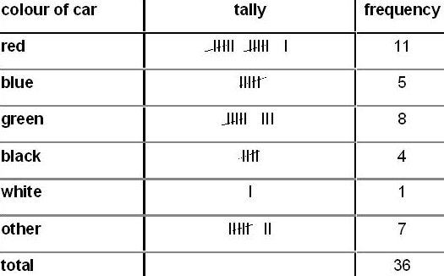
13. The colors of cars at NEMS are given in the frequency table. What is the most common color represented?

14. How many cars are represented?

15. Examine the line plot.
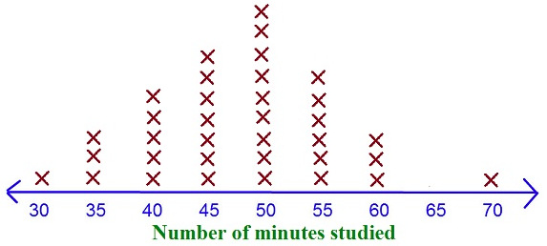
a) How many students are represented in the data set?

b) What is the median of the data set?

c) What does the median represent?

# of Students | Absolute Deviation
8
10
5
8
14
9
7
16. The following data set represents the number of students in each group on a recent field trip.

- Find the mean number of students per group.

b. Fill in the table to show the absolute deviations.

c. Determine the Mean Absolute Deviation:

17. Charlie and Isabelle are recording data on the temperatures in their towns this month. Charlie’s mean absolute deviation was 5.43 degrees per day. Isabella’s mean absolute deviation was 2.1 degrees per day. Describe which town has more consistent temperatures. Use what you know about variability and mean absolute deviation to explain your answer.

18. The mean absolute deviation for Anna’s test scores this year is 4.5. The mean absolute deviation for Evan’s test scores this year is 10.71. Who is a more consistent student? Use what you know about variability and mean absolute deviation to explain your answer.

19. Billy Bob’s test scores are 92, 90, 85, 91, 65, and 81. The mean of these values is 84. What is the mean absolute deviation of Billy Bob’s test scores? Show your work.

20. The follow numbers represent the number of absences for ten 6th grade students at NEMS.
8 20 15 4 0 18 7 8 3 5

a. Find the mean of the scores. What does the mean represent in relation to the data set?

b. Find the median of the scores. What does the median represent in relation to the data set?

21. Part A: Calculate the mean, median, and mode of the following hourly wages of different workers.
8.60, 9.50, 11.00, 10.25, 9.75, 9.00, 8.95, 10.00,

Mean = _______ Median = _______ Mode = _______

Part B: Which measure of central tendency should the workers use to convince their managers to raise their salaries?

22. Nicole and Tommy are comparing their weekly paychecks over the past two months.

Nicole -- 90, 32, 80, 91, 93, 84, 88, 79 Tommy – 95, 90, 83, 90, 82, 88, 77, 79

- Find the mean and median for Nicole’s and Tommy’s paychecks. Which measure of central tendency best describes Nicole’s pay? Which best describes Tommy’s pay? Explain.

- Compare the paychecks to determine who earned more, based on the measures of central tendency you selected in part a. Justify your answer.

