Review Guide for Assessment 6 (6th Grade Math)

6.EE.5 Use Substitution To Identify Solutions

1. Look at the following inequality: n + 5 > 14

Which value(s) of n from the set {5, 7, 9, 11, 13} make the inequality true? Explain your response.

2. Molly tutors 2 clients and earns more than $50. Using the inequality 2x > 50, which value from the set {$13, $19, $25, $32} represents how much money she earns per client? Show how you determined your answer.

A. 13 B. 19 C. 25 D. 32

6.EE.8 Write & Graph Inequalities

3. Emma has $32 in her savings account and wants to buy a set of toy trucks that cost at least $40. Let x represent the amount that Emma needs to save in order to have enough money to buy the toy trucks. Write an inequality to represent this situation.

4. Graph each inequality on the number lines provided.

a) m > 4 b) x < -3

c) b > -1 d) a < 8

5. Write an inequality that models each graph below:
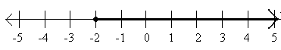
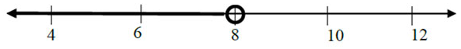
a) b)

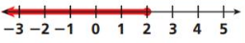
c) d)

6. For each situation, write an inequality, define your variable, and graph the solutions on a number line.

a) Carson spends no more than $45 at the movies.
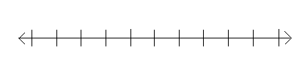
Variable:_______________________

Inequality:______________________

b) Jake needs at least $72 to go on the trip.
Variable:_______________________

Inequality:______________________

c) Megan earns less than $11.25 per hour.
Variable:_______________________

Inequality:______________________

d) Joe needs to sell 12 or more items this week to
meet his goal.
Variable:_______________________

Inequality:______________________

6.EE.9 Variables, Tables, & Graphs

7. Use the table to answer questions a – d.

Minutes (m) | Beads (b)
0 | 0
2 | 30
3 | 45
5 | 75

a) Graph the ordered pairs to represent the relationship between minutes and beads.

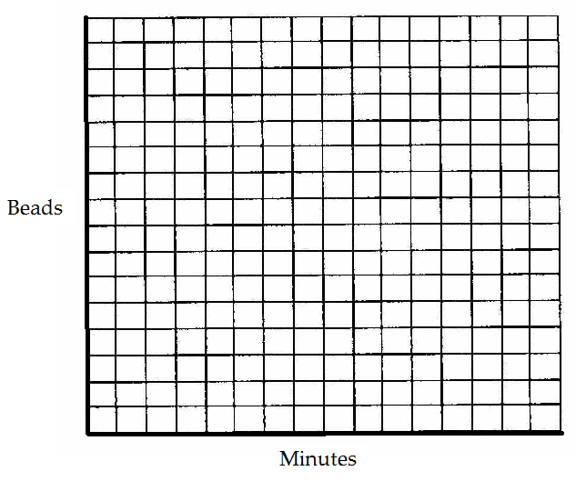

b) Write an equation to illustrate the relationship between the two variables.

c) How many beads would be made in 12 minutes?

8. A waitress earns $15 per hour. The equation y = 15x represents the amount that earns, y.

Part A: Complete the table below based on this relationship.
Hours Worked, x | Money Earned, y
0
4
10
15

Part B: Identify the independent and dependent variables.

Part C: How much money would she earn if she worked 80 hours?

9. Use the table to answer questions a – d.
# of hours (t) | 1 | 2 | 3 | 4
Distance in miles (d) | 40 | 80 | 120 | 160

a) How far do you travel each hour?

b) Which is the independent variable and which is the dependent variable? Explain why.

c) Write an equation to represent the relationship between the distance (d) and the # of hours (t).

d) Your destination is 100 miles away and you were hoping to arrive in 2 hours. Will you make it there? If not, explain how you know and when you will arrive. Justify your answer!

